**SCHOLARWISE**

**(Everything made easy)**

# 

*A university project report submitted by*

**Batch -17**

Palteru Kaushik (20181CSE9046)

Girish K C (20181CSE0228)

Gogineni Venkata Satvik(20181CSE0229) Gurucharan D A (20181CSE0254)

*as part of* ***Professional Practice******– II****,* ***PIP 102****,**of*

# BACHELOR OF TECHNOLOGY

*in*

# COMPUTER SCIENCE AND ENGINEERING

*under the supervision of*

Kiran S, Assistant Professor



DEPARTMENT OF COMPUTER SCIENCE AND ENGINEERING PRESIDENCY UNIVERSITY

Itgalpur Rajanakunte, Yelahanka, Bengaluru, Karnataka-560064

April 2022

**Table of Contents**

|  |  |  |
| --- | --- | --- |
| **Sl. No.** | **Contents** | **Pg. No.** |
| 1. | **Abstract** | 3 |
| 2. | **Literature survey** | 4 |
| 3. | **Objective** | 5 |
| 4. | **Existing Methods-Drawbacks** | 6 |
| 5. | **Proposed Method** | 7 |
| 6. | **Architecture Diagram** | 8 |
| 7. | **Modules** | 9 |
| 8. | **Hardware and Software details** | 10 |
| 9. | **Timeline by Gannt Chart** | 11 |
| 10. | **References** | 12 |

**Abstract:**

Today, the use of social media has become so prominent that we consider it as an integral part of our daily lives in this technology-driven era. Social media is a dynamic platform that can be used in so many ways to share knowledge, entertainment, news etc. Social media is not limited to just entertainment. When used correctly, people especially students can make use of it to make education more convenient by accessing useful information like academic resources, exam papers; and by connecting with fellow students, learning groups, teachers, alumni etc.

To tackle these problems, students have already been using various digital platforms like Superset and third-party LMS platforms for various purposes like connecting with students and teachers, sharing and accessing academic resources, placements and internships related news etc. Sometimes it becomes hassle for students to switch between these platforms to meet their requirements and purposes.

To solve this, we plan to develop a socio-academic portal “ScholarWise” for Presidency University students to provide a holistic solution to all student needs. Scholar Wise is a single stop for students to make use of their educational purposes like accessing academic resources such as study materials, PDFs, previous year question papers, competitive exam materials, and getting notified about various college events, internships and placement related opportunities.

**Literature survey:**

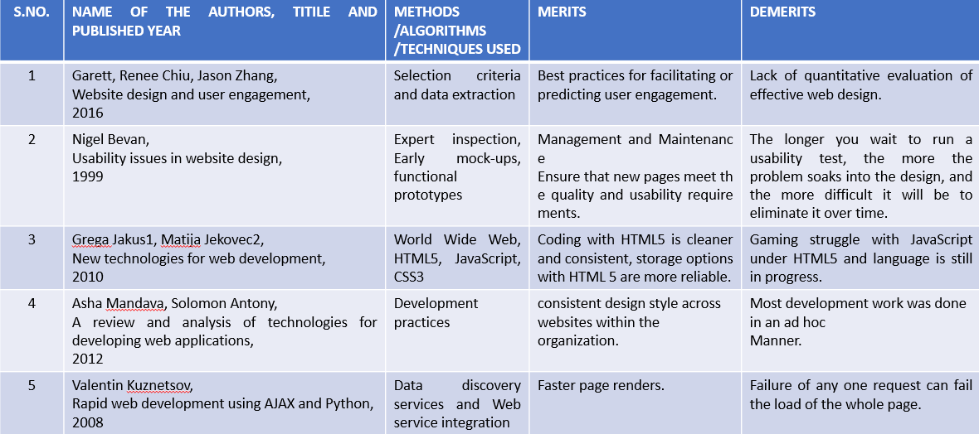

**Objective:**

**ScholarWise** is a socio-academic portal built for university students with an aim to provide a holistic solution to all student needs, the main objective of this project is to help students by providing them with each and every academic resource with a single click. The website helps the students to upload and access available study materials, PDFs, previous year question papers, competitive exam materials, timetables of their respective sections, etc. which helps them during exam time.

The website also facilitates the idea of notifying students about various college events, internships, and placement opportunities. Only the administrator, placement coordinators, and club presidents have permission to post events or info related to the events. Students can view those posts and reactions accordingly.

**Existing Methods-Drawbacks:**

In the existing websites such as space college provides access to educational resources, career opportunities, etc. in a limited way. College space posts the data by themselves that helps in student development. The major drawback is that they don’t allow users to post the information and also information related to tests, quizzes and assignments is not available. It doesn’t act as a social media interface, they don’t allow users to post information regarding clubs, events and, etc.

**Proposed Method:**

Now, **ScholarWise** is a socio academic platform that allows user to post information regarding clubs, events and webinars, etc. Every user can post information regardless of the user type like student or admin. In this platform everyone can post previous question papers, question paper samples, information regarding student clubs, webinars. Here a scholar can make use of it successfully while preparing for an exam or test. Here every student and teacher can post academic and non-academic information. Here people can even find the materials of some open electives that are rarely available.

**Architecture Diagram:**

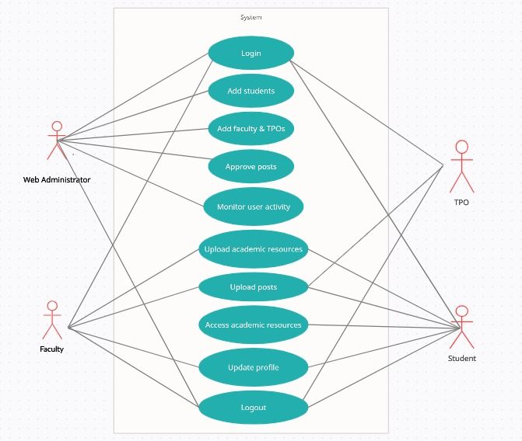

**Modules:**

The project includes three modules:

1. **Admin Module:**

In the Admin module, the system allows the admin to log in with a username and password. Admin dashboard is provided with a navbar menu that contains navigable items like Register Student, Register Faculty, Manage users, Approve posts, log in, and Logout.

1. **Faculty Module:**

In the Faculty module, the system allows the faculty members to log in with a username and password which have been provided by the Admin to faculty members. The faculty dashboard is provided with a navbar menu that contains navigable options like News Feed, Upload academic resources like study materials, exam papers, timetable, etc., upload posts in the newsfeed, update profile, log in, and logout.

a) **TPO Module:**

Faculty modules contain a sub-module “TPO” Module which is exclusive for only the college’s Training and Placement Officer (TPO). TPO dashboard is provided with options like Uploading placement and internships related information in the news feed.

1. **Student Module:**

In the Student module, the system allows the students to log in with username and password credentials that have been provided by the admin to students. The student dashboard is provided with a navbar menu that contains navigable options like News Feed, upload academic resources, upload posts in the news feed, access the academic resources, update profile, log in, and logout.

**Hardware and Software details:**

**MINIMUM HARDWARE REQUIREMENTS:**

* System : Pentium IV 2.4 GHz.
* Hard Disk : 40 GB.
* Monitor : 15-inch VGA Color.
* Mouse : Standard Mouse.
* Ram : 512 MB
* Keyboard : Standard Keyboard

**MINIMUM SOFTWARE REQUIREMENTS:**

* Operating System : Windows XP.
* Platform : Web Technology
* Tool : Notepad++, Sublime
* Front End : HTML, CSS, JavaScript, Bootstrap
* Back End : PHP, SQL

**Timeline by Gantt chart:**

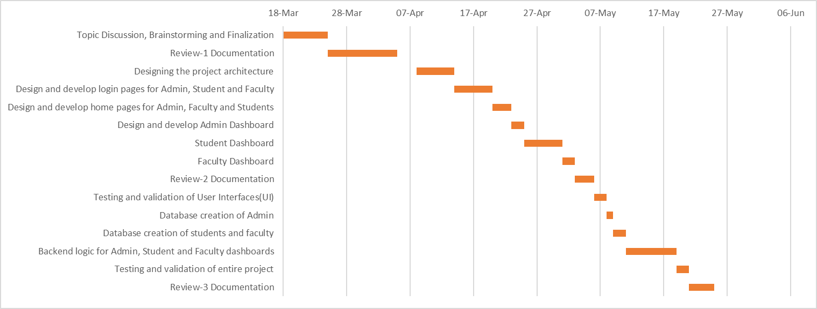

**References:**

1. <https://collegespace.netlify.app/>
2. <https://developer.mozilla.org/en-US/>
3. **Website design and user engagement** by Garett, Renee Chiu, Jason Zhang.
4. **Usability issues in website design** by Nigel Bevan.
5. **New technologies for web development** by Grega Jakus1, Matija Jekovec2.
6. **A review and analysis of technologies for developing web applications by** Asha Mandava, Solomon Antony.
7. **Rapid web development using AJAX and Python** by Valentin Kuznetsov.